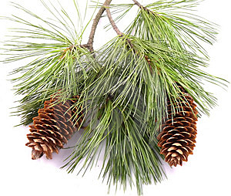
Welcome to
Pine Meadows

The residents of Pine Meadows welcome you
to our beautiful community.
Cliff and Wendy Bowman
36 White Bark Way

