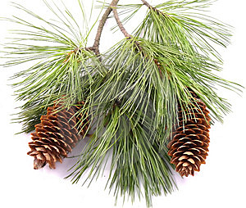
Welcome to
Pine Meadows

The residents of Pine Meadows welcome you
to our beautiful community.
Harry and Lily Douglas
129 Bristlecone Court

